**Erikkson**  
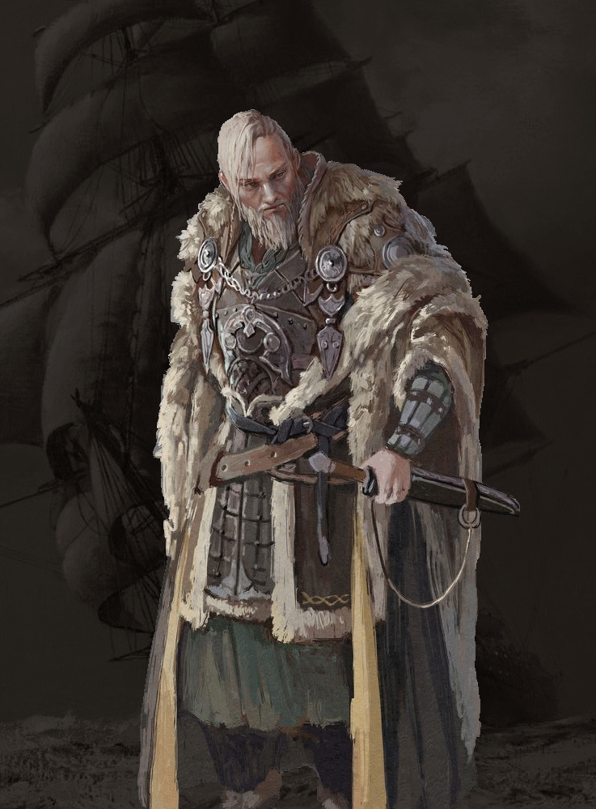Variant Human - Barbarian  
Tough Feat lvl 1  
Path of the Storm Herald - Storm Aura when Rage  
Sentinel feat

**Ødger**  
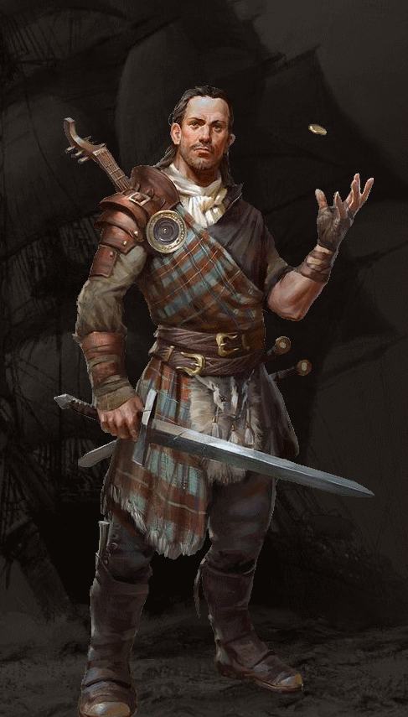Human – Bard  
College of Swords  
Dueling Fighting style  
Defensive Flourish only

**Ulfhild**  
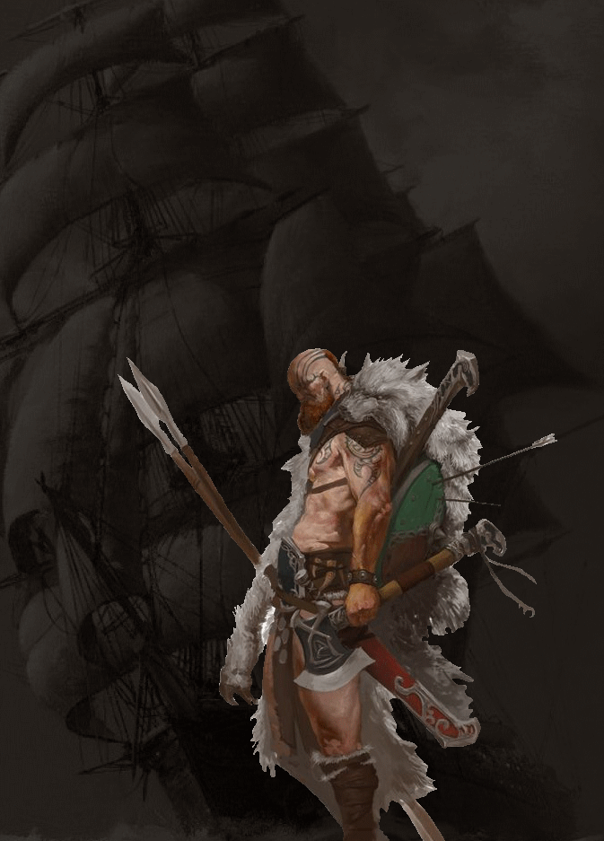Human – Fighter  
Blind Fighting fighting style  
Samurai Martial Archetype  
Polearm master feat

**Knud**  
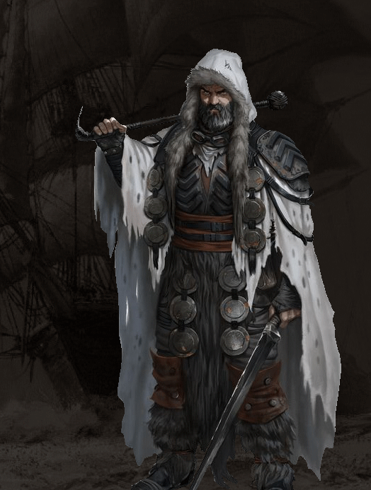Triton – Fighter  
Two weapon fighting style  
Brute Martial Archetype  
Dual wielder feat

**Leif**  
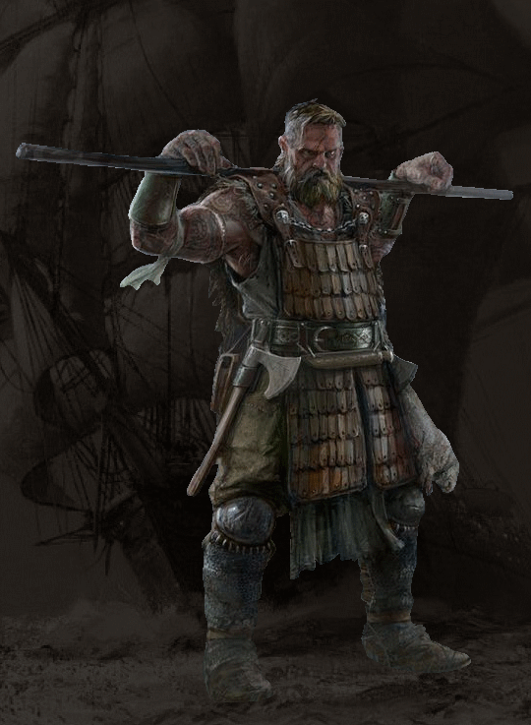Human – Fighter  
Unarmed Fighting Fighting style  
Scout Martial Archetype  
Tavern Brawler feat

**Troels**  
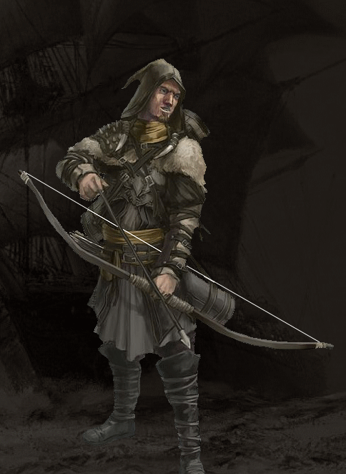Human - Fighter  
Archery Fighting style  
Arcane Archer  
Piercer Feat